
MT-0043

NITTO KOHKI CO., LTD.

Head Office

9-4, Nakaikegami 2-Chome, Ohta-ku, Tokyo 146-8555 Japan
TEL: +81-3-3755-1111
FAX: +81-3-3753-8791

E-mail: overseas@nitto-kohki.co.jp www.nitto-kohki.co.jp

April 28, 2017

Introducing Atra Ace model AO-5575A

The Atra Ace model AO-5575A, a renewal model of AO-5575, has just been released.

The main changes and features are as follows:
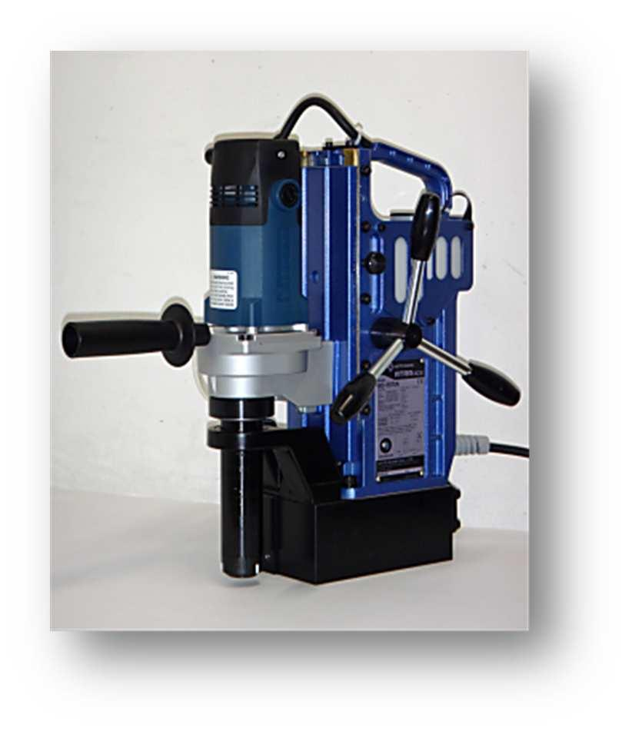

- Compact and lightweight by the change of the electric drill.
- Reduced motor power consumption, saves energy by 17%.

- Prevents gear selection mistakes by adopting a single speed type with optimum rotation speed. Gear selection is not required.

- The carbon brush and armature lasts longer by the improved motor structure.

For further specifications, please see the next page.

1 / 2


ATRA ACE Model: AO-5575A
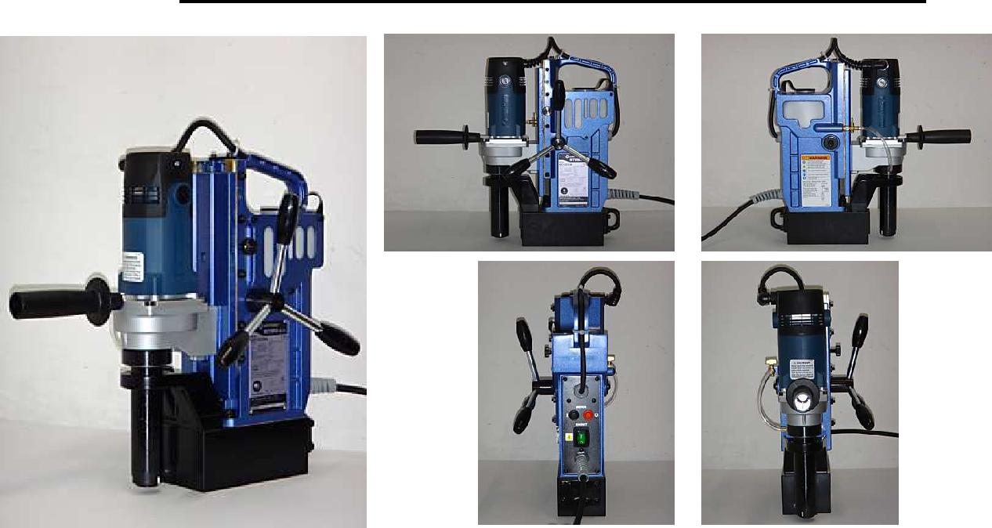

Specifications

 |  |  | Model | AO-5575A
1. | Power Source (Single Phase) |  |  | 220V - 240V AC, 50/60 Hz
 |  |  |  | Hole Diameter(mm) |  |  | Plate Thickness(mm)
 |  |  | One-touch Type JETBROACH | 17.5 to 55 |  |  | 9 to 75
2. | Hole Capacity
 |  |  |  | 12 to 17 |  |  | 9 to 50
 |  |  | One-touch Type HI-BROACH | 12 to 50 |  |  | 9 to 50
3. | Magnet Holding Power |  |  | 10,000 N
4. | Magnet Power Consumption |  |  |  |  | 50 W
5. | Magnet Dimensions |  |  | 86 mm x 170 mm
6. | Max. Stroke |  |  | 105 mm
7. | Mass (Weight) |  |  | 17.5 kg
8. | Dimension (W x H x D) |  |  | 197 mm x 399 mm x 296 mm
 |  |  | Rated Power Consumption |  | 950W
9. | Electric Drill |  | Rated Current |  | 4.3 A
 |  |  | No-load Speed |  | 520 RPM

Accessories

Pilot Pin 08050 | Spanner 8x10 | Chain
3mm Hex. Socket Screw Key | Cutting Oil 0.5L | Guard
5mm Hex. Socket Screw Key | Sub Handle

2 / 2

